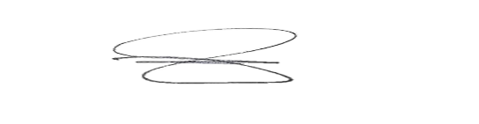

CIVIL STATUS :

BIRTHDAY :

BIRTH PLACE :

BLOOD TYPE :

RELIGION :

CELPHONE NO :

IN CASE OF EMERGENCY PLEASE NOTIFY:

NAME :

CONTACT NO:

RELATIONSHIP:

**HON. EDUARD G. TOLEDO**

PUNONG BARANGAY

LEFT

THUMBMARK

RIGHT

THUMBMARK

*VALID UNTIL: 12/31/2024*

SURNAME : **{{SURNAME}}**

FIRST NAME : {{FIRST_NAME}}

MIDDLE NAME : {{MIDDLE_NAME}}

ADDRESS : {{HOUSE_ADDRESS}}

**TRES CRUSES, TANZA, CAVITE**

SIGNATURE

*WARNING:*

*HEAVY PENALTY WILL BE IMPOSE FOR UNLAWFUL USE. IF FOUND, FINDER MUST PROMPTLY RETURN IT THE* ***TRES CRUSES BARANGAY HALL.***

*FOR VERIFICATION PLEASE CALL (046) 412-7245*

***CONTROL NO: 2024-09-1079***

***3***

REPUBLIC OF THE PHILIPPINES

PROVINCE OF CAVITE

MUNICIPALITY OF TANZA

**BARANGAY TRES CRUSES**